Lab 3: Component Modelling & Architectural Pattern Selection
Scenario #63 – Community Solar Credit Allocation Manager

Deliverable 1: UML Component Diagram
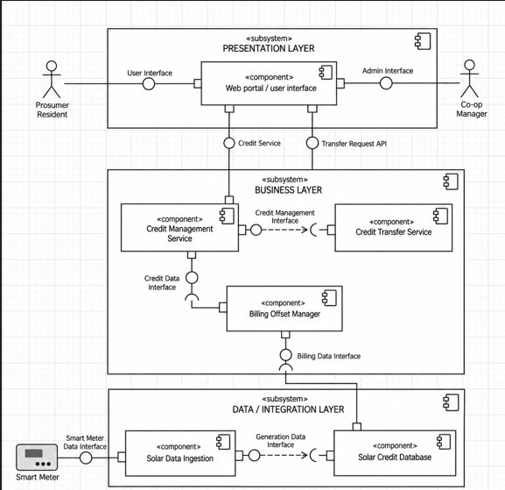

Deliverable 2: Written Justification
Architecture Selection – Community Solar Credit Allocation Manager
Architecture Selected: Layered Architecture
We chose Layered Architecture for the Community Solar Credit Allocation Manager.
Reasons for Selection
1. Clear separation of responsibilities:
Layered Architecture separates the system into Presentation, Business, and Data/Integration layers. This allows the Web Portal to handle user interaction, the Business Layer to manage credit transfers and billing offsets, and the Data/Integration Layer to handle smart-meter data and database operations.
2. Organized data and business processing:
The system needs to validate and store hourly solar generation data for 500 households, manage solar credit balances, support peer-to-peer credit transfers, and track monthly utility billing offsets. Layered Architecture provides a clear structure for managing these different responsibilities.
Security Advantage
Layered Architecture allows security controls to be applied at different layers. Authentication and authorization can be used to protect household credit information and prevent unauthorized users from performing credit transfers or accessing billing information.
Performance Benefit
Separating the data ingestion, business processing, and presentation responsibilities helps the system process hourly smart-meter generation data efficiently and supports the required workload of 500 households. This structured separation can also help the system meet the required 99.9% availability target.

Problem Statement: #63 – Community Solar Credit Allocation Manager
Architecture: Layered Architecture

